THE TWELVE YEAR PRAYERS
AS GIVEN TO SAINT BRIDGET OF SWEDEN

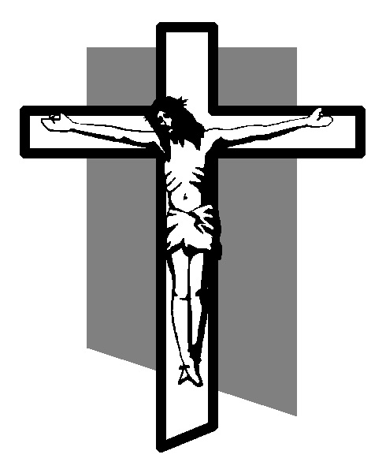
INTRODUCTION: ONE YEAR PRAYERS

Saint Bridget of Sweden prayed for a long time to know how many blows Our Lord, Jesus Christ, suffered during His terrible Passion. Rewarding her patience, one day Jesus appeared to her and said:

"I received 5475 blows upon My Body. If you wish to honor them in some way, recite fifteen Our Fathers and fifteen Hail Marys with the following Prayers, which I Myself shall teach you, for an entire year. When the year is finished, you will have honored each of My Wounds."

Our Lord also gave her these prayers to be recited for twelve years with five magnificent promises of salvation from Our Lady.

THE TWELVE YEAR PRAYERS

Prayers Honoring the 7 Times Jesus Spilled His Precious Blood for Us, as Revealed by Our Lady to St. Bridget of Sweden, and Approved by Pope Clement XII.

The Magnificent Promises of the 12 Year Prayers

1. The soul who prays them will suffer no Purgatory.

2. The soul who prays them will be accepted among the Martyrs as though he had spilled his blood for his faith.

3. The soul who prays them can choose three others whom Jesus will then keep in a state of grace sufficient to become holy.

4. No one in the four successive generations of the soul who prays them will be lost.

5. The soul who prays them will be made conscious of his death one month in advance.

** If the soul praying these prayers dies before the entire 12 years of prayers have been completed, the Lord will accept them as having been prayed in their entirety, because the intention of the soul was to complete them as directed. If a day or a few days are missed due to a valid reason, they can be made up for later, at the soul's earliest opportunity.

OPENING PRAYER

O Jesus, now I wish to pray the Lord's Prayer seven times in unity with the love with which You sanctified this prayer in Your Heart. Take it from my lips into Your Divine Heart. Improve and complete it so much that it brings as much honor and joy to the Trinity as You granted it on earth with this prayer. May these pour upon Your Holy Humanity in Glorification to Your Painful Wounds and the Precious Blood that You spilled from them.

FIRST PRAYER: THE CIRCUMCISION
Pray 1 Our Father, 1 Hail Mary, then:

Eternal Father, through Mary's unblemished hands and the Divine Heart of Jesus, I offer You the first wounds, the first pains, and the first Bloodshed as atonement for my and all of humanity's sins of youth, as protection against the first mortal sin, especially among my relatives. Amen

SECOND PRAYER: THE SUFFERING ON THE MOUNT OF OLIVES
|Pray 1 Our Father, 1 Hail Mary, then:

Eternal Father, through Mary's unblemished hands and the Divine Heart of Jesus, I offer You the terrifying suffering of Jesus' Heart on the Mount of Olives and every drop of His Bloody Sweat as atonement for my and all of humanity's sins of the heart, as protection against such sins and for the spreading of Divine and brotherly Love. Amen

THIRD PRAYER: THE FLOGGING
Pray 1 Our Father, 1 Hail Mary, then:

Eternal Father, through Mary's unblemished hands and the Divine Heart of Jesus, I offer You the many thousands of Wounds, the gruesome Pains, and the Precious Blood of the Flogging as atonement for my and all of humanity's sins of the Flesh, as protection against such sins and the preservation of innocence, especially among my relatives. Amen

FOURTH PRAYER: THE CROWNING OF THORNS
Pray 1 Our Father, 1 Hail Mary, then:

Eternal Father, through Mary's unblemished hands and the Divine Heart of Jesus, I offer You the Wounds, the Pains, and the Precious Blood of Jesus' Holy Head from the Crowning with Thorns as atonement for my and all of humanity's sins of the Spirit, as protection against such sins and the spreading of Christ's kingdom here on earth. Amen

FIFTH PRAYER: THE CARRYING OF THE CROSS
Pray 1 Our Father, 1 Hail Mary, then:

Eternal Father, through Mary's unblemished hands and the Divine Heart of Jesus, I offer You the Sufferings on the way of the Cross, especially His Holy Wound on His Shoulder and its Precious Blood as atonement for my and all of humanity's rebellion against the Cross, every grumbling against Your Holy Arrangements and all other sins of the tongue, as protection against such sins and for true love of the Cross. Amen

SIXTH PRAYER: THE CRUCIFIXION
Pray 1 Our Father, 1 Hail Mary, then:

Eternal Father, through Mary's unblemished hands and the Divine Heart of Jesus, I offer You Your Son on the Cross, His Nailing and Raising, His Wounds on the Hands and Feet and the three streams of His Precious Blood that poured forth from these for us, His extreme tortures of the Body and Soul, His precious Death and its non bleeding Renewal in all Holy Masses on earth as atonement for all wounds against vows and regulations within the Orders, as reparation for my and all of the world's sins, for the sick and the dying, for all holy priests and laymen, for the Holy Father's intentions toward the restoration of Christian families, for the strengthening of Faith, for our country and unity among all nations in Christ and His Church, as well as for the Diaspora. Amen

SEVENTH PRAYER: THE PIERCING OF JESUS' SIDE
Pray 1 Our Father, 1 Hail Mary, then:

Eternal Father, accept as worthy, for the needs of the Holy Church and as atonement for the sins of all Mankind, the Precious Blood and Water which poured forth from the Wound of Jesus' Divine Heart. Be gracious and merciful toward us.

Blood of Christ, the last precious content of His Holy Heart, wash me of all my and others' guilt of sin!

Water from the Side of Christ, wash me clean of all punishments for sin and extinguish the flames of Purgatory for me and for all the Poor Souls. Amen.

